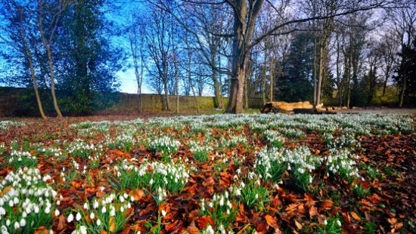

**Dear Friends and Supporters of Coventry Cathedral Chorus,**

Thank you to everyone who came to hear us in Coventry Cathedral for our two Christmas concerts. First, our ‘Christmastide Celebration’ with The Brass Band of Central England (formerly the award-winning Jaguar Land Rover Brass Band) and Heart of England Secondary School, and secondly, Handel’s ‘Messiah’ withOrchestra Pro Anima. We hope you enjoyed the variety of music and collaborations; our thanks to all the musicians and singers who joined us to make both concerts a success.

Looking ahead to Easter, our next concert is entitled **‘Music for Good Friday’** on **Friday, 29th March 2024** at **6pm**. Against the backdrop of the magnificent tapestry of Christ the Redeemer in **Coventry Cathedral**, we will sing a selection of beautiful and inspiring motets for Good Friday, reflecting upon the Easter themes of love, sacrifice and hope. Under the baton of Rachel Mahon, Coventry Cathedral Chorus’ Director of Music, and joined by our soloist Joseph Banerjee, we will offer music from across the 17th, 19th and 20th centuries. Our programme features contrasts of musical style, from the ethereal layers of sound within Purcell’s ‘Hear my Prayer’ to the dissonant quality found in John Sanders’ ‘The Reproaches’.

You can buy your tickets via:

* <https://www.coventrycathedralchorus.com>
* Ticketweb on 0844 477 1000.
* Jill Pacey, CCC’s ticket officer, email: [tickets@coventrycathedralchorus.com](mailto:tickets@coventrycathedralchorus.com) or telephone: 01676 532436.

Tickets bought in advance will cost £20 (half price for students). Tickets bought on the door will cost £25.

Future dates for your diary:

* ‘**Last Night of the Proms’** with Coventry and Warwickshire Youth Orchestra on **Saturday, May 11th** at **7pm** in **Coventry Cathedral.**
* **‘Festal Evensong’** on **Saturday 22nd June** at **4pm** in **Coventry Cathedral,** to celebrate the 60th Jubilee of the Chorus.We will welcome our President, Pam Rhodes, to give a reading as part of the programme. We look forward to singing music by Wood, Martin, Stanford, Parry and Elgar.

Finally, please bear in mind that we are always on the lookout for new members. [www.coventrycathedralchorus.com](http://www.coventrycathedralchorus.com)

Thank you for your interest and support, and we look forward to seeing you at a concert soon!

**Rachel**  **Coventry Cathedral Chorus Director of Music**

**Kit Chair of Coventry Cathedral Chorus**